Name ______________________

Dew Point | the temperature at which air is saturated
Evaporation | when a water molecule gets warm enough to become water vapor and rise into the air
Condensation | When a gas changes into a liquid (like water vapor into a water drop in a cloud)
Humidity | the amount of water vapor in the air
Precipitation | water falling from the sky as rain, sleet, snow or hail
Relative Humidity | the percentage of water vapor in the air at a certain temperature
Water vapor | water in the gas form – or - moisture in the air
Weather | the condition of the atmosphere at a certain time and place

Name ______________________

Weather Precipitation Dew Point Water vapor
Evaporation Humidity Relative humidity Condensation

________________ | the amount of water vapor in the air
________________ | water falling from the sky as rain, sleet, snow or hail
________________ | the percentage of water vapor in the air at a certain temperature
________________ | water in the gas form – or - moisture in the air
________________ | when a water molecule gets warm enough to become water vapor and rise into the air
________________ | the temperature at which air is saturated
________________ | the condition of the atmosphere at a certain time and place
________________ | When a gas changes into a liquid (like water vapor into a water drop in a cloud)
Name ______________________
Label this illustration:
Wind, conduction, convection, radiation – draw arrows on the convection cell – draw the person’s hair – finish the paragraph

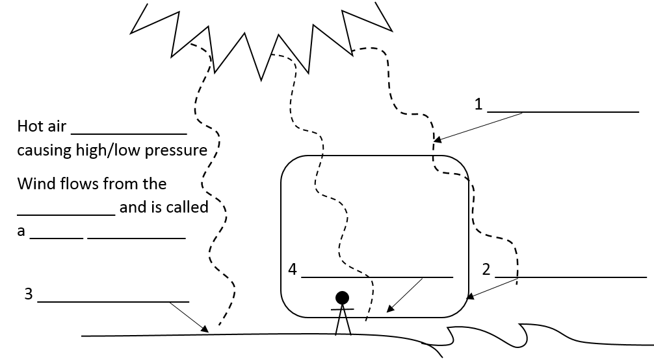

- Draw a star on the trade winds
- Circle the line at the doldrums
- Draw an arrow pointing to the
horse latitudes
- Draw the North American
Jet Stream where we
would expect it to be.
- Draw the convection belt
between the equator & 30° S

Name ______________________
Label this illustration:
Wind, conduction, convection, radiation – draw arrows on the convection cell – draw the person’s hair – finish the paragraph

- Draw a star on the trade winds
- Circle the line at the doldrums
- Draw an arrow pointing to the
horse latitudes
- Draw the North American
Jet Stream where we
would expect it to be.
- Draw the convection belt
between the equator & 30° S

Name ______________________
Label this illustration:

Condensation evaporation precipitation
runoff transpiration filtration

Humidity is the amount of water in the air. Warm air has molecules that are very spread out – so lots of water can fit inside of it. As air cools down the water no longer fits in the air – so it begins to condense into water droplets. When those water droplets get large enough they fall as precipitation.

- Which type of air holds the most water? (hot or cold) _________________
- Clouds are made up of water ______________________.
- Clouds are caused by condensation when the air gets ______________________ (colder or warmer)
- Use the illustration above to list the processes that raise humidity. ____________________________________

Name ______________________
Label this illustration:

Condensation evaporation precipitation
runoff transpiration filtration

Humidity is the amount of water in the air. Warm air has molecules that are very spread out – so lots of water can fit inside of it. As air cools down the water no longer fits in the air – so it begins to condense into water droplets. When those water droplets get large enough they fall as precipitation.

- Which type of air holds the most water? (hot or cold) _________________
- Clouds are made up of water ______________________.
- Clouds are caused by condensation when the air gets ______________________ (colder or warmer)
- Use the illustration above to list the processes that raise humidity. ____________________________________

Put it all together…
What we already know about weather
- We know that Biomes are large areas with similar temperature, wind and precipitation. Weather is local temperature, wind and precipitation that occurs on a specific day. Weather occurs in biomes, but when we talk about the weather we really don’t care if it is snowing in another part of our biome – we only care about what is happening here.
- We know that temperature is determined by how much sunlight hits earth’s surface and that wind is caused by convection cells when the warm ground warms the air through conduction.
- And we know that precipitation is because there is always water vapor in the air – and that the water vapor clumps together as raindrops when it gets too cold in the upper troposphere.
So when you think about it some of the weather that we see makes a lot of sense. Once you get wind blowing anywhere you will cause winds in other places. When the wind is blowing it is changing the temperatures of the land and air around it.
And once you change the temperature of air you change how much water it can hold – if you make the air colder the water in it will condense into drops and eventually fall as precipitation.
- Biomes describe an area by temp., wind and precipitation. How is weather different?

- What are the three ways that things on earth get warm? (hint: convection is one)
- Precipitation is connected with temperature. Water stays in the air until the air gets_________________(colder, hotter)
- Once you change the temperature of air you change how much
Put it all together…
What we already know about weather
- We know that Biomes are large areas with similar temperature, wind and precipitation. Weather is local temperature, wind and precipitation that occurs on a specific day. Weather occurs in biomes, but when we talk about the weather we really don’t care if it is snowing in another part of our biome – we only care about what is happening here.
- We know that temperature is determined by how much sunlight hits earth’s surface and that wind is caused by convection cells when the warm ground warms the air through conduction.
- And we know that precipitation is because there is always water vapor in the air – and that the water vapor clumps together as raindrops when it gets too cold in the upper troposphere.
So when you think about it some of the weather that we see makes a lot of sense. Once you get wind blowing anywhere you will cause winds in other places. When the wind is blowing it is changing the temperatures of the land and air around it.
And once you change the temperature of air you change how much water it can hold – if you make the air colder the water in it will condense into drops and eventually fall as precipitation.
- Biomes describe an area by temp., wind and precipitation. How is weather different?

- What are the three ways that things on earth get warm? (hint: convection is one)
- Precipitation is connected with temperature. Water stays in the air until the air gets_________________(colder, hotter)
- Once you change the temperature of air you change how much
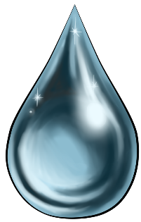
Humidity
Water vapor is always in the air around us, but the amount of water vapor in the air is really important to weather patterns.
When air is warm it can hold a whole lot of water vapor, but when the air cools down it can’t hold as much water and that water vapor begins to condense into raindrops. That’s why, on a hot summer day, we get thunderstorms. The very wet hot air rises until it cools down and the water condenses. Because the air was hot it had a lot of water in it so when it cools and condenses the rain is heavy.
We call the amount of water in the air humidity.
Humidity depends upon two things – the amount of water available and the temperature of the air.
Air that is as full of water as it can get is called saturated air. Warm air is saturated when it contains huge amounts of water. Cool air is saturated when it has only a small amount of water in it. Either way – air that is saturated will cause clouds and eventually precipitation - if the temperature drops even a little bit.
Relative humidity has to do with the amount of water air can hold at a specific temperature.
Huh?
If a sponge can hold 1 cup of water at 70 degrees then it is saturated if is actually has 1 cup of water in it (at 70 degrees). Saturated air has 100% humidity.
But if that same sponge (at 70 degrees) only has ½ a cup of water in it then that would have 50% humidity.
- Warm air can hold a whole lot of _____________________ but cool air can’t hold as much.
- Humidity depends upon _____________________________ and _________________________.
Humidity
Water vapor is always in the air around us, but the amount of water vapor in the air is really important to weather patterns.
When air is warm it can hold a whole lot of water vapor, but when the air cools down it can’t hold as much water and that water vapor begins to condense into raindrops. That’s why, on a hot summer day, we get thunderstorms. The very wet hot air rises until it cools down and the water condenses. Because the air was hot it had a lot of water in it so when it cools and condenses the rain is heavy.
We call the amount of water in the air humidity.
Humidity depends upon two things – the amount of water available and the temperature of the air.
Air that is as full of water as it can get is called saturated air. Warm air is saturated when it contains huge amounts of water. Cool air is saturated when it has only a small amount of water in it. Either way – air that is saturated will cause clouds and eventually precipitation - if the temperature drops even a little bit.
Relative humidity has to do with the amount of water air can hold at a specific temperature.
Huh?
If a sponge can hold 1 cup of water at 70 degrees then it is saturated if is actually has 1 cup of water in it (at 70 degrees). Saturated air has 100% humidity.
But if that same sponge (at 70 degrees) only has ½ a cup of water in it then that would have 50% humidity.
- Warm air can hold a whole lot of _____________________ but cool air can’t hold as much.
- Humidity depends upon _____________________________ and _________________________.
Rain Fog Sleet Cumulus Snow
Stratus Hail Cumulonimbus Cirrus

__________________ | puffy white clouds with flat bottoms – bring fair weather until they turn dark
__________________ | layered clouds that cover a large area
__________________ | Thin, feathery clouds high in the atmosphere
__________________ | a cloud that forms near the ground
__________________ | dark cumulus clouds that cause thunderstorms
__________________ | the most common form of precipitation
__________________ | frozen rain
__________________ | precipitation that is made of balls of ice
__________________ | water vapor that changes directly into a solid without becoming liquid
Name that cloud
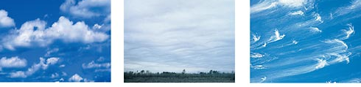
________________ ________________ _______________
Rain Fog Sleet Cumulus Snow
Stratus Hail Cumulonimbus Cirrus

__________________ | puffy white clouds with flat bottoms – bring fair weather until they turn dark
__________________ | layered clouds that cover a large area
__________________ | Thin, feathery clouds high in the atmosphere
__________________ | a cloud that forms near the ground
__________________ | dark cumulus clouds that cause thunderstorms
__________________ | the most common form of precipitation
__________________ | frozen rain
__________________ | precipitation that is made of balls of ice
__________________ | water vapor that changes directly into a solid without becoming liquid
Name that cloud
________________ ________________ _______________
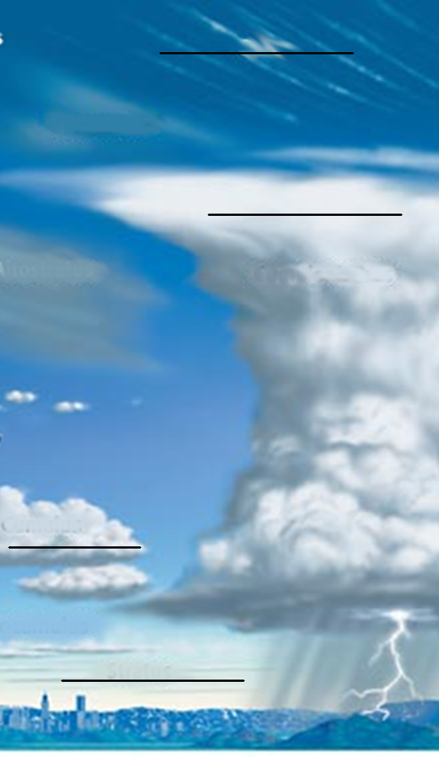
Label: stratus, cumulonimbus, cirrus and cumulus
Label: stratus, cumulonimbus, cirrus and cumulus

