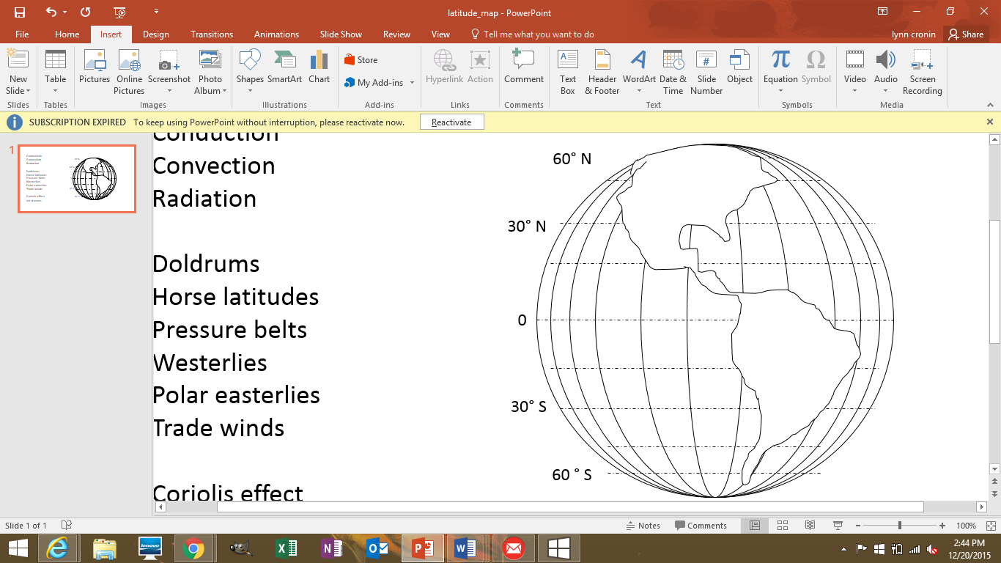111

Convection

Radiation

Equator

Doldrums

Horse latitudes (2)

Pressure belts

Westerlies

Polar easterlies

Trade winds

Coriolis effect

Jet streams