WC (Weather and Climate) Chapter 1.1

The Atmosphere
- Layered into four major layers – like the liquid layers
- Always changing – photosynthesis, breathing, pollution, temperature
- 78% N (nitrogen) 21% O (oxygen) 1% everything else (H₂O, CO₂, argon, dust, smoke etc.)
- 700 meters tall (435 miles)
Atmospheric Pressure
- The column of molecules above us press us down
  - Think of a column of popcorn, the bottom would be crushed the top loose
  - We each carry as much weight as a small car
- There are many molecules crushed at the bottom of the atmosphere and very few scattered around the top of the atmosphere.
- Just like in the ocean, the pressure is greatest at the bottom. We know that a water bottle filled at the top of the water will crush as it sinks into the ocean. Our atmosphere works the same way.
- This water bottle was closed at the top of a mountain. The climber then walked down. 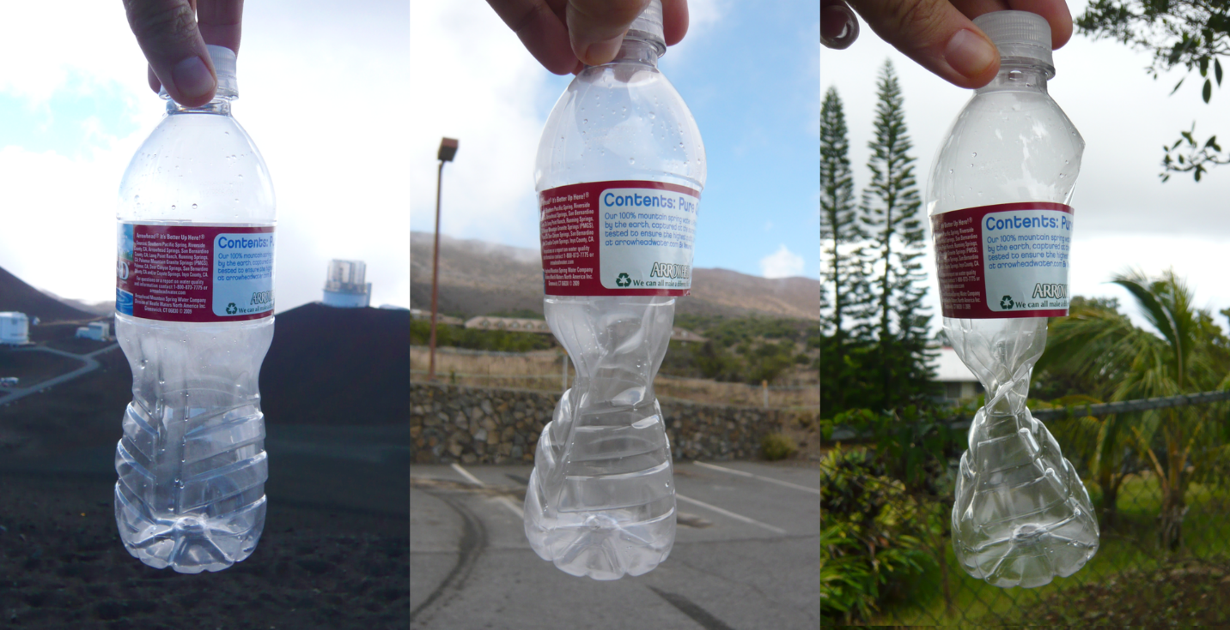

Layers of the Atmosphere - Each layer is a sphere around the earth – end in “sphere”
- Layered by density – just like the liquid layers
- Troposphere
  - 90% of the mass of the whole atmosphere (think more molecules)
  - Contains H₂O, CO₂ clouds, pollution, weather and life
  - About 15 km tall (9.3 miles – here to the Deptford mall)
  - Gets colder as it goes up – but it constantly mixes because heat rises
- Stratosphere – (strato means layered)
  - Layered
  - Cold at bottom – heats as it rises because chemicals absorb heat differently
  - Contains the bottom of the ozone layer
    - Ozone layer – gasses absorb radiation and get warm – traps radiation to protect us from UV damage
- Mesosphere (meso means middle)
  - The coldest atmospheric layer
  - Colder at top
  - Very few molecules to bang into each other and release heat
- Thermosphere (thermos means heat)
  - Considered the hottest layer – because nitrogen and oxygen absorb solar radiation and get very hot….
    - but there are not enough molecules to release energy – so it is actually cold - if we took a thermometer full of molecules out there it would register as very, very hot
  - Contains the ionosphere
    - Ionosphere – at the top of the mesosphere and bottom of the thermosphere
    - N & O collect so much solar radiation that the gas turns into plasma and glows (neon lights are plasma)
    - AM Radio waves bounce off the ionosphere so we can get radio signals from all the way around the world
WC (Weather and Climate) Chapter 1.2
Understanding Weather
- Heat Transfer
  - Radiation – moves on waves like light 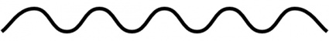
  - Conduction – hot vibrating molecules touch each other and transfer the vibrations as heat
  - Convection – hot rises, cold sinks causes a stirring
- The water cycle – radiation warms water which rises and warms the air around it (conduction). As the air cools it begins to sink again stirring the atmosphere (convection)
- Greenhouse effect
- light arrives from the sun as short wave energy. It warms the air and the earth’s surface (water and land) That heat spreads to other areas of land and water through conduction. It rises and sinks through convection. This causes the water cycle, which causes clouds. Clouds allow warm air to bounce back to earth and the whole planet stays warm enough for life to exist.
- The clouds act as the roof of the greenhouse.
- Radiation Balance
  - The amount of radiation that enters earth’s atmosphere also escapes it – or else we would get too hot
- Global Warming WARNING: our textbook was published in 2007 - it was written in the very early 2000’s. While the science was already clear, the politics of the United States made it impossible for a book publisher to write that global warming was definitely a problem.
  - Global Warming – the primary warming gasses in our atmosphere are H₂O and CO₂ – they both hold heat well, but CO₂ holds it better.
  - Since the industrial revolution began in the early 1800s, we have been pumping huge amounts of CO₂ into our atmosphere.
  - This release of CO₂ has caused world temperatures to rise by about 1.33°F – which does not sound like much but …
    - In the past one degree down was enough to push us into an ice age
    - We will see more severe storms and severe drought as the weather patterns change
    - Ecosystems are changing as some life forms can no longer live in an area
    - In the western United States and Canada, the pine beetle has been able to live much further north than ever before. National Geographic predicts that 60% of the pine trees in British Columbia will die.
    - Coral reef are bleaching

