Volcanoes! Name ________________________

- A volcano is a _________________ in earth’s crust that allows ___________ to escape.
- The release of magma from a volcano is called an __________________.
- Magma is the layer of _______________ ___________ that lies just below earth’s crust.
- The melted rock is very ______ and ___________ as it melts putting ______________ on the rock above.
- As the magma gets hotter it gets ___________________ and burns a _________ through the rock above it.
- That’s the main ____________.
- The top of the main vent is rock that acts like a _______ until the pressure gets too ___________ and it __________________.
- _________________ spills out and __________ escape as an _______________ cloud.
- Name the three types of volcano
- ________________________________
- ________________________________
- ________________________________
- ___________________ volcanoes don’t _______________ - they ____________.
- The lava spreads out and ______________ up _____________ with _____________, gently sloping sides.
- __________________ is built from _____________ volcanoes.
- ________________ _____________ volcanoes are the _______________ volcanoes.
- They are made of small bits of ___________ that erupt into the air and ______________ before they hit the ground.
- The whole volcano is like a large __________________ pile.
- __________________ volcanoes are what you think of when you think of a volcano.
- They are made from ______ __________________ types of eruptions.
- Sometimes composite volcanoes ___________ like shield volcanoes leaving layers of hard ___________________.
- Sometimes they ____________ like cinder volcanoes – that leaves layers of ___________.
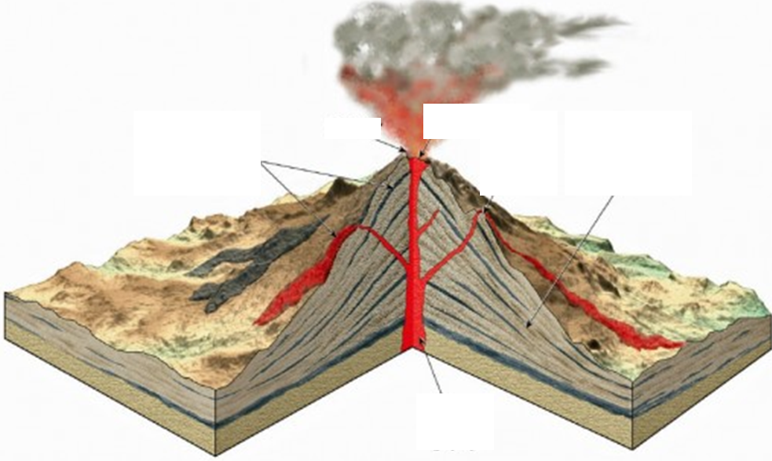
- Label this illustration of a volcano.
- What is another name for Ash and Lava? ______________________________________
- The ash flow (pyroclastic flow) is up to _______________ degrees.
- It races down the mountain at _____________ miles per hour.
- Even if you are not anywhere near an explosion the ash can be ____________.
- In 1991 the ash from Mount _____________________ in the Philippines reached the top of the _________________________!
- The ash cloud ____________________ earth for several years and the temperatures dropped by ______ to ______ degree!
- When mount Tambora erupted in 1815 it caused global cooling. Name three things that happend
- _______________________________________
- _______________________________________
- _______________________________________
Volcanoes! Review Name ________________________
- Explain how a volcano erupts
____________________________________________________________________________________________________________________________________
- Name the three types of volcano and describe each. (include size and composition)

- What is the most dangerous part of a volcanic eruption? Why?
____________________________________________________________________________________________________________________________________

- Use the vocabulary at the bottom to label this illustration of a volcano.

Main Vent Ash Lava Side Vent Crater
Name _________________________________

Use these vocabulary words to fill in the blank.
Volcano | Eruption | Magma | Main Vent
Side Vent | Shield Volcano | Cinder Cone Volcano | Composite Volcano
Pyroclastic Material | Global Cooling

- anything that escapes a volcano – ash or lava
- a volcano that is a combination of both types of volcano
- a volcano that oozes lava – very large with gently sloping sides. Like Hawaii
- when a pyroclastic ash cloud shadows earth and causes earth to cool down for a few years.
- smaller tunnels that branch off the main vent
- the layer of melted rock beneath earth’s crust
- the release of pyroclastic material from an earthquake
- the tunnel through a volcanic mountain where magma escapes
- a small volcano made of gravel (lava that hardened before it hit the ground)
- a fault in earth’s crust that allows pyroclastic material to escape.

