National Geographic Science
Pages – 116-121

Unit Five Earth Science
Lesson 1 Weather

Essential Question:
What is weather? _________________________________________________________
________________________________________________________________________
________________________________________________________________________

Tell 3 ways that weather can change  _______________________________  _______________________________  _______________________________  _______________________________ | Define: Weather  ____________________________________  ____________________________________________________________________________________________________________

What words do we use to describe weather? ________________________________
________________________________________________________________________
________________________________________________________________________

Describe the craziest weather day that you remember. (Use our weather words)
________________________________________________________________________
________________________________________________________________________
________________________________________________________________________

How do measure weather?
rain gauge
anemometer
wind vane
thermometer
barometer

____________________________________ measure temperature
____________________________________ measure wind direction
____________________________________ measure wind speed
____________________________________ measure air pressure
____________________________________ measure rain amount

National Geographic Science
Not in our textbook

Unit Five Earth Science
Lesson 1 Weather

What is our atmosphere?
_______________________________________________________________________
________________________________________________________________________
________________________________________________________________________

Why do we have weather? | What is the air at the north pole like? (temp.) | What is the air at the equator like? (temp)

What happened when you placed the ice cube into the room temperature water? _______________________________________________________________________
________________________________________________________________________
________________________________________________________________________

What happened when you added hot water into the room temperature water? _______________________________________________________________________
________________________________________________________________________
________________________________________________________________________

Did the two masses of water (one hot and one cold) mix right away | Did the water stay completely still as you added hot and cold, or did it move? How did it move? (draw your answer)
National Geographic Science
Page 125

Unit Five Earth Science
Lesson 1 Weather

What is a cold air mass? ___________________________________  ___________________________________ | What is a hot air mass? ______________________________________________________________________

How is wind made? ___________________________________  ___________________________________ | Which air mass holds a lot of water? ______________________________________________________________________

When a warm, wet air mass gets cooler, what happens?
________________________________________________________________________
________________________________________________________________________

Label this illustration:
Terms:
hot
lightning
wind
rain
cold

Add arrows to show how the clouds will move.

Essential Question:
What is weather? (how does it form?) _______________________________________
________________________________________________________________________
________________________________________________________________________
________________________________________________________________________ ________________________________________________________________________
National Geographic Science Unit Five Earth Science
Draw the front lines and label the weather on the map in day 3. Make sure you label the weather and temperature in New Jersey.
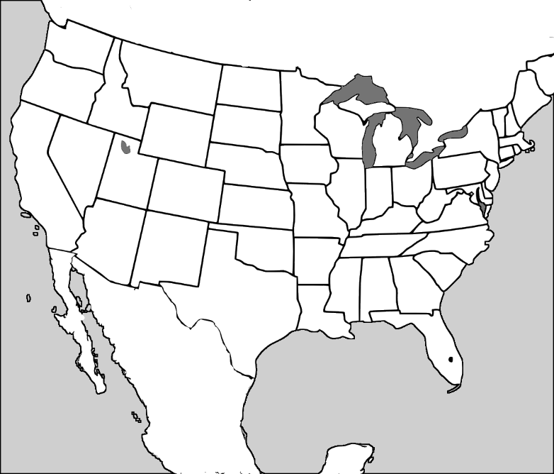
90˚
80˚
70˚
60˚
50˚
40˚
30˚
20˚
90˚
45˚
55˚
50˚
90˚
80˚
70˚
60˚
50˚
40˚
30˚
20˚
70˚
30˚
45˚
40˚
90˚
80˚
70˚
60˚
50˚
40˚
30˚
20˚
Day 3

Day 2

Day 1

National Geographic Science
Pages – 126-127
Unit Five Weather
Lesson 5 Seasons

Essential Question:
What are seasons? ________________________________________________________
________________________________________________________________________ ________________________________________________________________________
________________________________________________________________________

What are the seasons at the North Pole? Why are they called that?  __________________________________  ________________________________________________________________________________________________________________________________________ | What are the seasons near the equator?  ____________________________________  ____________________________________________________________________________________________________________

We saw a map of the seasons of the earth. Which zone are we in?
________________________________________________________________________

Name the seasons in order starting with Winter
_________________________________ __________________________________
_________________________________ __________________________________

What factors do scientists use to measure seasonal changes?
_______________________________________________________________________

Why do scientists measure temperature twice each day?
_______________________________________________________________________
_______________________________________________________________________

National Geographic Science
Pages – 132 – 133

Unit Five Weather
Lesson 6 Climate

Essential Question:
How are climate and weather different? ______________________________________ _______________________________________________________________________ _______________________________________________________________________ _______________________________________________________________________

What would you pack for….
Vermont _______________________________________________________________
South Florida ___________________________________________________________ Ohio __________________________________________________________________

It snowed in Georgia this winter. Should we expect snow every year? Why?
_______________________________________________________________________
_______________________________________________________________________

What are the 3 main reasons for climate?
1. _____________________________________________________________________
_______________________________________________________________________
2. _____________________________________________________________________
_______________________________________________________________________
3. _____________________________________________________________________
_______________________________________________________________________

How is the climate in Yuma Arizona different than in Portland Oregon? Why? _______________________________________________________________________
_______________________________________________________________________

How is the climate in Syracuse, New York different than in St. Petersburg, Florida? Why? __________________________________________________________________
_______________________________________________________________________

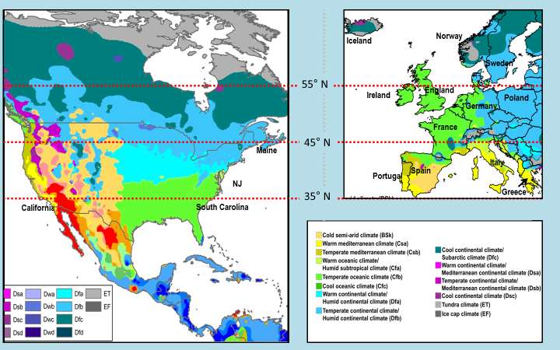
The dotted lines show latitude. Latitude is a measurement of how far away from the equator a location is. Every city that is near 35˚N should have similar climate. Look at the color map on your whiteboard to compare the climate of areas that are on the same latitude lines. What do you notice about areas near 35˚N in the U.S. versus Europe?
______________________________________________________________________
_______________________________________________________________________

Can you find a country in Europe that has similar weather to South Carolina? What factors tell you that it is similar? ____________________________________________ _______________________________________________________________________

Sweden is very far north of Maine, but they have a very similar climate. How could you explain that? Think about the 3 reasons for climate).
_______________________________________________________________________ _______________________________________________________________________ _______________________________________________________________________ _______________________________________________________________________
National Geographic Science
Pages – 136-141

Unit Five Weather
Lesson 7 Weather Hazards

Essential Question:
Name 3 weather hazards and how to protect yourself from them? _________________ _______________________________________________________________________ _______________________________________________________________________ _______________________________________________________________________
_______________________________________________________________________

Define: Weather Hazard__________________________________________________ _______________________________________________________________________
_______________________________________________________________________

How can a thunderstorm be hazardous? How can you protect yourself ______________
_______________________________________________________________________
_______________________________________________________________________
_______________________________________________________________________

What is a hurricane? How can it be hazardous? What should you do to stay safe? _______________________________________________________________________
_______________________________________________________________________
_______________________________________________________________________
_______________________________________________________________________

What do our cities and states do to protect us from flooding? ____________________
_______________________________________________________________________

Which water system is made of concrete? ____________________________________ Which water system is made of dirt? ____________________________________

How is wind a weather hazard? What can we do to protect ourselves?
_______________________________________________________________________
_______________________________________________________________________
National Geographic Science
Unit Five Weather
Lesson 7 Weather Hazards – Think like a scientist

With your group
Decide upon at least three changes that you would make to the beach house that you have just inherited and explain why those changes would keep your family safer. _______________________________________________________________________ _______________________________________________________________________ _______________________________________________________________________
_______________________________________________________________________
_______________________________________________________________________ _______________________________________________________________________ _______________________________________________________________________
_______________________________________________________________________
_______________________________________________________________________ _______________________________________________________________________ _______________________________________________________________________
_______________________________________________________________________
_______________________________________________________________________ _______________________________________________________________________ _______________________________________________________________________
_______________________________________________________________________
_______________________________________________________________________ _______________________________________________________________________ _______________________________________________________________________
_______________________________________________________________________
_______________________________________________________________________ _______________________________________________________________________ _______________________________________________________________________
_______________________________________________________________________

