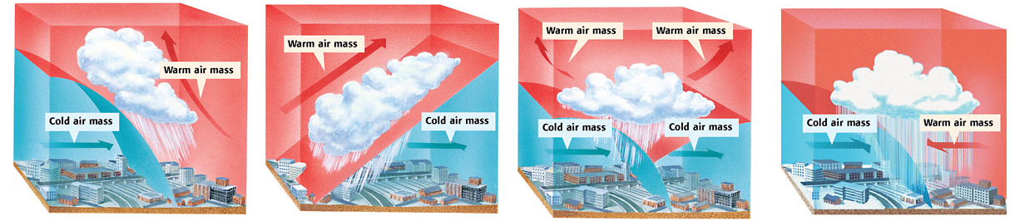
Name of front:  ____________________________  Where is the precipitation?  ____________________________  What weather will follow this front?  ____________________________  ____________________________  What kind of weather does this front produce?  ____________________________  ____________________________  ____________________________  ____________________________  ____________________________ | Name of front:  ____________________________  Where is the precipitation?  ____________________________  What weather will follow this front?  ____________________________  ____________________________  What kind of weather does this front produce?  ____________________________  ____________________________  ____________________________  ____________________________  ____________________________ | Name of front:  ____________________________  Where is the precipitation?  ____________________________  What weather will follow this front?  ____________________________  ____________________________  What kind of weather does this front produce?  ____________________________  ____________________________  ____________________________  ____________________________  ____________________________ | Name of front:  ____________________________  Where is the precipitation?  ____________________________  What weather will follow this front?  ____________________________  ____________________________  What kind of weather does this front produce?  ____________________________  ____________________________  ____________________________  ____________________________  ____________________________

