Earth’s Structure

- Earth’s interior is made of several layers – label them 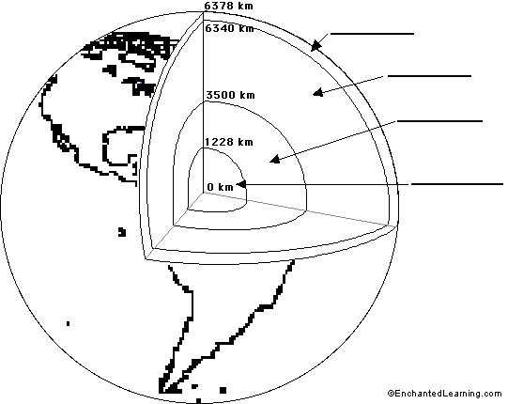
- When did scientists begin to understand what earth was made of?
- What did they study to figure it out?
- What is the inner core made of?
- Is the inner core solid or liquid?
- What is the outer core made of?
- Is the outer core solid or liquid?
- What two regions is the mantle divided into?
- What is the rock in the mantle like?
- The outside layer of the mantle is called the
- What is the rock here like?

- Describe the lithosphere

- What is the crust kinda lke? Why?

- Describe continental crust
- Describe oceanic crust

- Draw an image of continental crust and oceanic crust below. Label the ocean, the sea floor and the continental crust.

- Describe continental crust

- Describe oceanic crust

- Where do we live?

