FIRE!
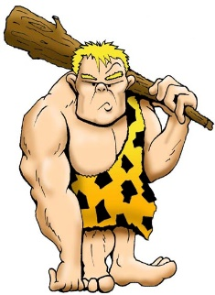
When man first figured out how to use fire they began to be the most powerful animal on the planet.
Fire allowed humans to sleep safely and during the night. It allowed more human beings lived to adulthood – so that they could have children. This was the beginning of human population growth.
Fire allowed humans to digest their meat easier – leaving energy for their brains to use. So we could focus on creating language and technology and art. We could become fully human.
But it is our inventions that have really set us apart from animals; cell phones, automobiles and even spaceships.
All of these inventions all involve energy of some sort.
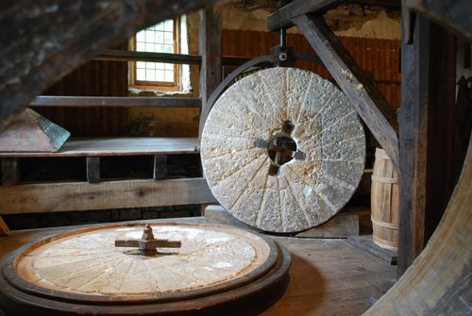
Until about a hundred years ago most of our inventions used energy directly. Water mills were used a thousand years ago to spin heavy equipment. They were first used to turn heavy rocks to crush corn or wheat into flour.
The idea of spinning something is used all the time – it is used in windmills and even in making electricity.
- When did man begin to become the most
powerful animals on earth?
- Fire allowed humans to focus on
- All human inventions require
- Water mills were used to
FIRE!
When man first figured out how to use fire they began to be the most powerful animal on the planet.
Fire allowed humans to sleep safely and during the night. It allowed more human beings lived to adulthood – so that they could have children. This was the beginning of human population growth.
Fire allowed humans to digest their meat easier – leaving energy for their brains to use. So we could focus on creating language and technology and art. We could become fully human.
But it is our inventions that have really set us apart from animals; cell phones, automobiles and even spaceships.
All of these inventions all involve energy of some sort.
Until about a hundred years ago most of our inventions used energy directly. Water mills were used a thousand years ago to spin heavy equipment. They were first used to turn heavy rocks to crush corn or wheat into flour.
The idea of spinning something is used all the time – it is used in windmills and even in making electricity.
- When did man begin to become the most
powerful animals on earth?
- Fire allowed humans to focus on
- All human inventions require
- Water mills were used to
Name
ES 5.2 Vocabulary
Anthracite | Bituminous | Non-Renewable Resource
Fossil Fuels | Lignite | Natural Gas
Peat | Petroleum | Recycling
Smog | Coal | Renewable Resource

- A fossil fuel that is made from ancient organisms
– a gaseous mixture of hydrocarbons
- A liquid mixture of hydrocarbons used a
fuel - formed from the remains of ancient,
microscopic, sea organisms
- A resource that can be replaced at the
same rate it is used
- A resource that forms at a rate
that is much slower than the rate
at which it is consumed
- A solid fossil fuel that is formed from
ancient decomposed plants
- Coal, oil and natural gas
- It’s like dry, crumbly grass – it
eventually turns into coal
- Peat that has been heated and
pressed on – the first stage of coal
- Reusing waste or scrap materials
- The main air pollution – caused by burning
petroleum (from cars)
- The most pure coal – it is the hardest and
burns very well 90% carbon
- The softest coal – eventually forms anthracite
Name
ES 5.2 Vocabulary
Anthracite | Bituminous | Non-Renewable Resource
Fossil Fuels | Lignite | Natural Gas
Peat | Petroleum | Recycling
Smog | Coal | Renewable Resource

- A fossil fuel that is made from ancient organisms
– a gaseous mixture of hydrocarbons
- A liquid mixture of hydrocarbons used a
fuel - formed from the remains of ancient,
microscopic, sea organisms
- A resource that can be replaced at the
same rate it is used
- A resource that forms at a rate
that is much slower than the rate
at which it is consumed
- A solid fossil fuel that is formed from
ancient decomposed plants
- Coal, oil and natural gas
- It’s like dry, crumbly grass – it
eventually turns into coal
- Peat that has been heated and
pressed on – the first stage of coal
- Reusing waste or scrap materials
- The main air pollution – caused by burning
petroleum (from cars)
- The most pure coal – it is the hardest and
burns very well 90% carbon
- The softest coal – eventually forms anthracite
ENERGY! Man began using equipment like watermills thousands of years ago and they used that technology for everything from cutting lumber to creating huge textile mills.
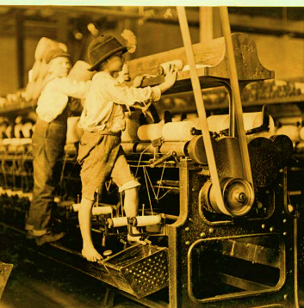
These boys are using a textile machine that is powered by water. Notice the belt at the end – it’s connected to a spinning wheel outside the building!
Until the mid-1800s humans used this kind of mechanical energy to create amazing inventions, but we could not use this energy to create trains and cars.
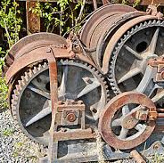
We already used oil and coal to light lamps and stoves– so we knew that it would heat water.
The first trains used coal to boil water – when the steam rose it hit a wheel – like the water mill – to turn shafts. When you add gears to this you can make train wheels turn! This invention drove the Industrial Revolution.
- What kind of energy do water mills use?
- Trains used steam energy – is it a mechanical energy? (Why or why not?)

- What do you think wind mills were used for?

ENERGY! Man began using equipment like watermills thousands of years ago and they used that technology for everything from cutting lumber to creating huge textile mills.
These boys are using a textile machine that is powered by water. Notice the belt at the end – it’s connected to a spinning wheel outside the building!
Until the mid-1800s humans used this kind of mechanical energy to create amazing inventions, but we could not use this energy to create trains and cars.
We already used oil and coal to light lamps and stoves– so we knew that it would heat water.
The first trains used coal to boil water – when the steam rose it hit a wheel – like the water mill – to turn shafts. When you add gears to this you can make train wheels turn! This invention drove the Industrial Revolution.
- What kind of energy do water mills use?
- Trains used steam energy – is it a mechanical energy? (Why or why not?)

- What do you think wind mills were used for?

Name
ES 5.2 Vocabulary
Anthracite | Bituminous | Non-Renewable Resource
Fossil Fuels | Lignite | Natural Gas
Peat | Petroleum | Recycling
Smog | Coal | Renewable Resource

- The most pure coal – it is the hardest and
burns very well 90% carbon
- Peat that has been heated and
pressed on – the first stage of coal
- A liquid mixture of hydrocarbons used a
fuel - formed from the remains of ancient,
microscopic, sea organisms
- A solid fossil fuel that is formed from
ancient decomposed plants
- Coal, oil and natural gas
- It’s like dry, crumbly grass – it
eventually turns into coal
- A fossil fuel that is made from ancient organisms
– a gaseous mixture of hydrocarbons
- A resource that forms at a rate
that is much slower than the rate
at which it is consumed
- Reusing waste or scrap materials
- The main air pollution – caused by burning
petroleum (from cars)
- A resource that can be replaced at the
same rate it is used
- The softest coal – eventually forms anthracite
Name
ES 5.2 Vocabulary
Anthracite | Bituminous | Non-Renewable Resource
Fossil Fuels | Lignite | Natural Gas
Peat | Petroleum | Recycling
Smog | Coal | Renewable Resource

- The most pure coal – it is the hardest and
burns very well 90% carbon
- Peat that has been heated and
pressed on – the first stage of coal
- A liquid mixture of hydrocarbons used a
fuel - formed from the remains of ancient,
microscopic, sea organisms
- A solid fossil fuel that is formed from
ancient decomposed plants
- Coal, oil and natural gas
- It’s like dry, crumbly grass – it
eventually turns into coal
- A fossil fuel that is made from ancient organisms
– a gaseous mixture of hydrocarbons
- A resource that forms at a rate
that is much slower than the rate
at which it is consumed
- Reusing waste or scrap materials
- The main air pollution – caused by burning
petroleum (from cars)
- A resource that can be replaced at the
same rate it is used
- The softest coal – eventually forms anthracite
ENERGY! The earliest cars also used steam energy – but it was a pain to shovel coal into a boiler, and the engines kept blowing up.
But someone figured something else out.
They began using a fuel that was similar to the kerosene that they used in oil lamps. They called it gasoline. It works by exploding inside a small box – when the explosion occurs it pushes rods out of the box and spins wheels in the engine.
Notice that human energy use still requires spinning. If you could get a river to run alongside your car, you could probably run the engine!
But now it gets really cool – if you want to make electricity – get something to spin! Really!
If you spin a magnet inside a tube that is wrapped with lot of copper wire – the wire picks up electricity. If you connect that to a light bulb – it lights!
When you shake this flashlight it causes the magnet to spin inside the coiled wire.
Most of our electricity is made from burning coal to spin a generator, but you can make a generator work with other things – like shaking the flashlight or with the heat from the sun.
Of course, you can use the spinning of a water or wind mill!
- We first started using gasoline
when what was invented?
- How do you create electricity?
ENERGY! The earliest cars also used steam energy – but it was a pain to shovel coal into a boiler, and the engines kept blowing up.
But someone figured something else out.
They began using a fuel that was similar to the kerosene that they used in oil lamps. They called it gasoline. It works by exploding inside a small box – when the explosion occurs it pushes rods out of the box and spins wheels in the engine.
Notice that human energy use still requires spinning. If you could get a river to run alongside your car, you could probably run the engine!
But now it gets really cool – if you want to make electricity – get something to spin! Really!
If you spin a magnet inside a tube that is wrapped with lot of copper wire – the wire picks up electricity. If you connect that to a light bulb – it lights!
When you shake this flashlight it causes the magnet to spin inside the coiled wire.
Most of our electricity is made from burning coal to spin a generator, but you can make a generator work with other things – like shaking the flashlight or with the heat from the sun.
Of course, you can use the spinning of a water or wind mill!
- We first started using gasoline
when what was invented?
- How do you create electricity?

