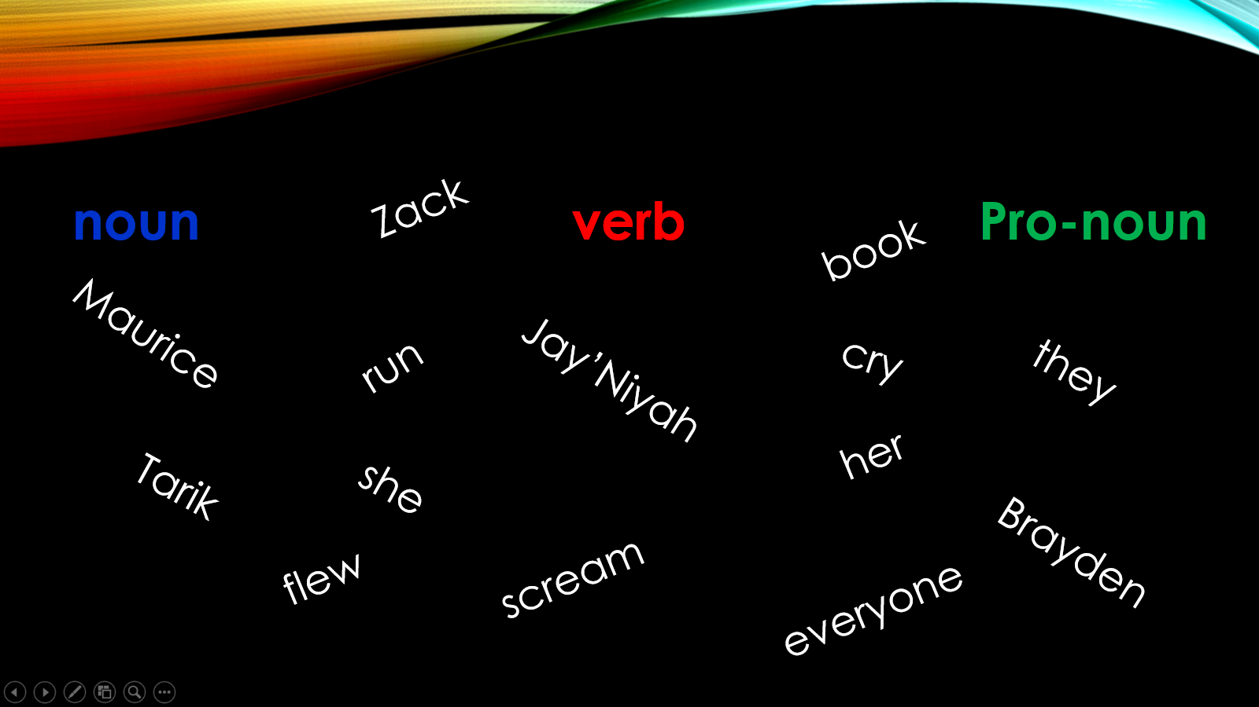
Noun Verb Pro-Noun
________________ _______________ ______________
________________ _______________ ______________
________________ _______________ ______________
________________ _______________ ______________
________________ _______________ ______________
________________ _______________ ______________
________________ _______________ ______________
________________ _______________ ______________
________________ _______________ ______________
________________ _______________ ______________

