Producers are plants – they make their own food energy through photosynthesis by using chemicals inside of their cells and combining that with sunlight. All plants are producers.
Consumers Animals are called consumers. This is because they cannot make their own food, so they need to consume (eat) plants and/or animals.
There are three types of consumers:
Herbivores are animals that eat only plants | carnivores are animals that eat only other animals | omnivores are animals that eat both plants and animals
Some examples of consumers are:
Herbivores:
Carnivores:
Omnivores

Scavengers are consumers that eat dead or decaying thing. Some eat just dead animals and other eat dead plants. Scavengers help us to recycle things that have died. Scavengers help to make dead things small enough that decomposers can do their jobs.
Scavengers:
vultures | flies | Hyenas

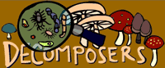
Decomposers
Bacteria and fungi are decomposers. They eat decaying matter - dead plants and animals and in the process they break them down and decompose them When that happens, they release nutrients and mineral salts back into the soil - which then will be used by plants!
Decomposers:
Mushrooms (fungus) | bacteria | mold

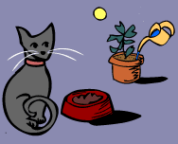
The Food Chain
Every living thing needs energy in order to live. Every time animals do something (run, jump) they use energy to do so.
Animals get energy from the food they eat, and all living things get energy from food. Plants use sunlight, water and nutrients to get energy (in a process called photosynthesis). Energy is necessary for living beings to grow.
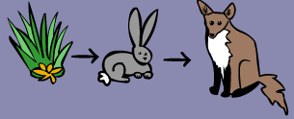
A food chain shows how each living thing gets food, and how nutrients and energy are passed from creature to creature. Food chains begin with plant-life, and end with animal-life. Some animals eat plants, some animals eat other animals.

A simple food chain could start with grass, which is eaten by rabbits. Then the rabbits are eaten by foxes.
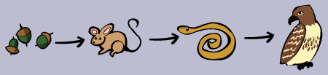
Bigger Food Chains Here's another food chain, with a few more animals. It starts with acorns, which are eaten by mice. The mice are eaten by snakes, and then finally the snakes are eaten by hawks. At each link in the chain, energy is being transferred from one animal to another.
There can be even more links to any food chain. Here another animal is added. It goes Grass to grasshopper to mouse to snake to hawk.
There is actually even more to this chain. After a hawk dies, fungi (like mushrooms) and other decomposers break down the dead hawk, and turn the remains of the hawk into nutrients, which are released into the soil. The nutrients (plus sun and water) then cause the grass to grow. It's a full circle of life and energy!!
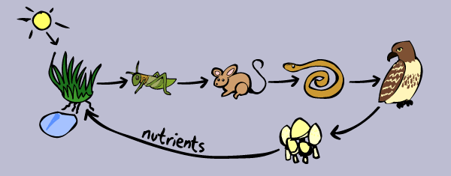
Take a look at these food chains.
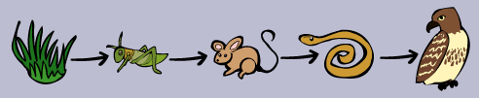

If you combined these two food chains you would have two producers (grass and acorns) and two primary consumers (crickets and mice) but only one secondary consumer (snakes) and only one tertiary consumer (the hawk)
Here is an example of a food web from your textbook
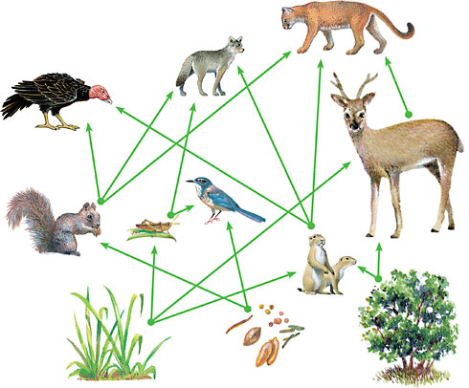
Can you draw a food web using the two food chains at the top of this page?

