the temperature at which air is saturated  Dew Point | the amount of water vapor in the air  Humidity | water in the gas form  – or –  moisture in  the air  water vapor | puffy white clouds with flat bottoms – bring fair weather until they turn dark  cumulus | a cloud that forms near the ground  fog (stratus) | frozen rain  Sleet | Name that cloud  cirrus
when a water molecule gets warm enough to become water vapor and rise into the air  Evaporation | water falling from the sky as rain, sleet, snow or hail  Precipitation | the condition of the atmosphere at a certain time and place  Weather | layered clouds that cover a large area  status | dark cumulus clouds that cause thunderstorms  cumulonimbus | precipitation that is made of balls of ice  hail | Name that cloud  stratus
When a gas changes into a liquid (like water vapor into a water drop in a cloud)  Condensation | the percentage of water vapor in the air at a certain temperature  Relative Humidity | Name that cloud  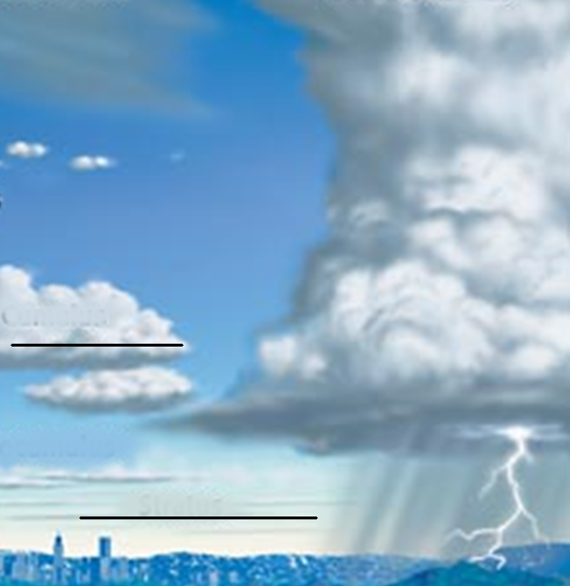  cumulonimbus | Thin, feathery clouds high in the atmosphere  cirrus | the most common form of precipitation  rain | water vapor that changes directly into a solid without becoming liquid  snow | Cumulus

