National Geographic Science
Pages – 116-121
Unit Five Earth Science
Lesson 1 Weather

Essential Question:
What is weather? _________________________________________________________
You can use the definition below or you can wait until we are done with tomorrow’s experiment to decide together what to write – that is what I will do
________________________________________________________________________
________________________________________________________________________

Tell 3 ways that weather can change  _______________________________  day to day hour to hour season to season  _______________________________  _______________________________  _______________________________ | Define: Weather  the conditions of the atmosphere (air) at a specific time and place.  ____________________________________  ____________________________________________________________________________________________________________

What words do we use to describe weather? ________________________________

FOR THE WEATHER CHART – fill out 2 with the kids with words like hot, strong wind, no wind etc. just get them thinking about to describe and measure weather
________________________________________________________________________
Temp., cloud cover, wind, precip. and humidity.
________________________________________________________________________

Describe the craziest weather day that you remember. (Use our weather words)
________________________________________________________________________
________________________________________________________________________
________________________________________________________________________

How do measure weather?

rain gauge
anemometer
wind vane
thermometer
barometer

____________________________________ measure temperature
Thermometer - temp
wind vane – wind direction
anemometer – wind speed
barometer – air pressure
rain gauges – rain amount
____________________________________ measure wind direction
____________________________________ measure wind speed
____________________________________ measure air pressure
____________________________________ measure rain amount

National Geographic Science
Not in our textbook
Unit Five Earth Science
Lesson 1 Weather

What is our atmosphere?
HEAT
the layer of “air” around Earth – all weather happens here
the cold water sank then ran across the bottom of the water – it eventually started moving up – but only because it ran out of bottom space.

the hot water immediately rose to the top and floated above the room temperature water
(eventually the two water masses will meet and begin to mix – but it takes a while
Water that falls out of warm air
hot
cold
Hot (or hot and wet)
no
cold
_______________________________________________________________________
________________________________________________________________________
________________________________________________________________________

Why do we have weather? | What is the air at the north pole like? (temp.) | What is the air at the equator like? (temp)

What happened when you placed the ice cube into the room temperature water? _______________________________________________________________________
________________________________________________________________________
________________________________________________________________________

What happened when you added hot water into the room temperature water? _______________________________________________________________________
________________________________________________________________________
________________________________________________________________________

Did the two masses of water (one hot and one cold) mix right away | Did the water stay completely still as you added hot and cold, or did it move? How did it move? (draw your answer)
National Geographic Science
Page 125
Unit Five Earth Science
Lesson 1 Weather

What is a cold air mass? ___________________________________  A blob of cold air – like over the north pole  ___________________________________ | What is a hot air mass? ______________________________________________________________________  A blob of hot air – like over the equator

How is wind made? ___________________________________  When hot meets cold the air “mixes” just like the water did – the mixing is wind.  ___________________________________ | Which air mass holds a lot of water? ______________________________________________________________________  Warm air – that’s why we feel humidity in the summer – there is a lot of water in summer air.

When a warm, wet air mass gets cooler, what happens?
The water in the warm air mass falls out of the sky – it is called rain, snow, sleet or hail. – technical term: precipitation
________________________________________________________________________
________________________________________________________________________

Label this illustration:
lightning
Terms:
hot
lightning
wind
rain
cold

Add arrows to show how the clouds will move.

cold
rain

wind
hot

Essential Question:
What is weather? (how does it form?) _______________________________________
Wheater happens when a cold air mass meets a warm air mass. The cold sinks and the hot rises causing wind. When they rub together they form lightning. When the warm gets cold water “falls” out making rain.
________________________________________________________________________
________________________________________________________________________
________________________________________________________________________ ________________________________________________________________________
National Geographic Science Unit Five Earth Science
Draw the front lines and label the weather on the map in day 3. Make sure you label the weather and temperature in New Jersey.
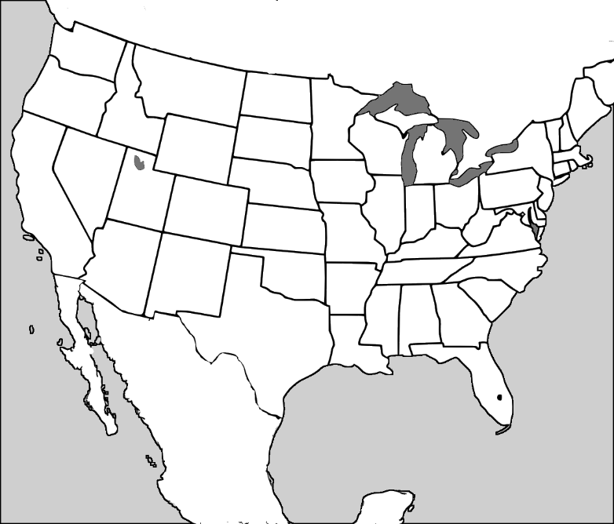
90˚
80˚
70˚
60˚
50˚
40˚
30˚
20˚
90˚
45˚
55˚
50˚
90˚
80˚
70˚
60˚
50˚
40˚
30˚
20˚
70˚
30˚
45˚
40˚
90˚
80˚
70˚
60˚
50˚
40˚
30˚
20˚
Day 3

Day 2

Day 1

if you look at the top two maps the cold (triangle) line is very high on the first but has moved down on the second

the hot (half circle) line is very low over florida on the first, but has moved up into the Carolina’s for the second

When day three is draw I expect that the kids will draw the lines together so that they can then draw lighting and rain.
I would guess that the weather in NJ to be 70 but I would also grade this very easy

National Geographic Science
Pages – 126-127
Unit Five Weather
Lesson 5 Seasons

Essential Question:
What are seasons?________________________________________________________
Seasons are caused by the tilt of our earth as it revolves around the sun.
Some parts of the world have 2 seasons - others have 4
________________________________________________________________________ ________________________________________________________________________
________________________________________________________________________

What are the seasons at the North Pole? Why are they called that?  __________________________________  Polar Day and Polar Night  because there are times of the year when there is no sunlight at all during the day  ________________________________________________________________________________________________________________________________________ | What are the seasons near the equator?  The wet season and the dry season  ____________________________________  ____________________________________________________________________________________________________________

We saw a map of the seasons of the earth. Which zone are we in?
________________________________________________________________________
Mid-Latitudes

Name the seasons in order starting with Winter
_________________________________ __________________________________
_________________________________ __________________________________

What factors do scientists use to measure seasonal changes?
Temperature and precipitation
_______________________________________________________________________

Why do scientists measure temperature twice each day?
_______________________________________________________________________
Because it is very cold at night and warm during the day
_______________________________________________________________________

30˚

50˚

Some students might not notice that the red upper bar is the high for the day and the second blue bar is the low

so on this sample in black and white,
the light color is the low of 30
and the high is the darker color of 50
(that way we can draw the high and the low for each day on the same bar)

Make sure the kids label the graph and each axiz
National Geographic Science
Unit Five Weather
Lesson 6 Climate

Essential Question:
How are climate and weather different? ______________________________________ _______________________________________________________________________ _______________________________________________________________________ _______________________________________________________________________
Climate describes what kind of weather we could expect in an area during a specific time of year. It will never tell you what to expect on a specific day. Weather tells you if you need to pack sunscreen or an umbrella on a specific day.
Example: Average May daytime weather for Washington Township NJ is 65˚ and sunny!

What would you pack for….
Vermont _______________________________________________________________
ski clothes with mittens and a snowboard
a snorkel, a bathing suit
warm coats, mittens and hats – maybe a snowboard but it might not snow
no Fla. too warm

South Florida ___________________________________________________________ Ohio __________________________________________________________________

It snowed in Georgia this winter. Should we expect snow every year? Why?
_______________________________________________________________________
NO! The snow this year was just an abnormal weather event. the typical climate of Georgia in the winter says it will probably be about 60˚ in the winter.

_______________________________________________________________________

What are the 3 main reasons for climate?
1. _____________________________________________________________________
_______________________________________________________________________
Climate depends upon how close you are to the equator (latitude)

How close you are to sea level (or how far up a mountain – it gets colder as you go up)

If you are next to a large body of water (especially if it is on your west!)
2. _____________________________________________________________________
_______________________________________________________________________
3. _____________________________________________________________________
_______________________________________________________________________

How is the climate in Yuma Arizona different than in Portland Oregon? Why? _______________________________________________________________________
Yuma is desert / Portland is humid and mild. (Portland is being effected by the Pacific Ocean so it is not as cold as a northern city could be.)

_______________________________________________________________________

How is the climate in Syracuse, New York different than in St. Petersburg, Florida? Why? __________________________________________________________________
Syracuse is very far north and is on a great lake – they get a lot of lake effect snow in Syracuse where the air over the lakes grabs up water and as soon as the air goes over the land it drops (average snowfall 123.8” per year!!!) St. Pete’s is in Florida and is gorgeous!

_______________________________________________________________________

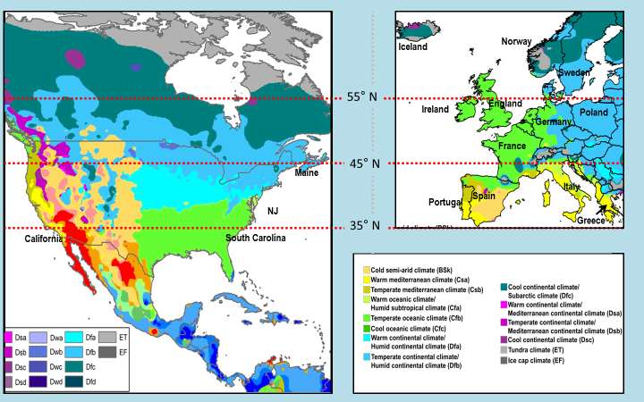
The dotted lines show latitude. Latitude is a measurement of how far away from the equator a location is. Every city that is near 35˚N should have similar climate. Look at the color map on your whiteboard to compare the climate of areas that are on the same latitude lines. What do you notice about areas near 35˚N in the U.S. versus Europe?
______________________________________________________________________
_______________________________________________________________________

Can you find a country in Europe that has similar weather to South Carolina? What factors tell you that it is similar? ____________________________________________ _______________________________________________________________________
The south of Spain, Greece, the toe of Italy – they are colored the same
the lime green areas in the U.S. are south of us. the green areas in Europe are at or above us. If we were the same as Europe the weather in NJ should be like that of Southern Spain or Greece

Sweden is very far north of Maine, but they have a very similar climate. How could you explain that? Think about the 3 reasons for climate).
_______________________________________________________________________ _______________________________________________________________________ _______________________________________________________________________ _______________________________________________________________________
- close to equator – Maine is way closer – should be much warmer
- both areas seem to be at similar levels above sea level
- both are next to a large body of water – but only Sweden has the water to it’s left – the ocean is probably moderating their temperature.
National Geographic Science
Pages – 136-141

Unit Five Weather
Lesson 7 Weather Hazards

Essential Question:
Name 3 weather hazards and how to protect yourself from them? _________________ _______________________________________________________________________ _______________________________________________________________________ _______________________________________________________________________
_______________________________________________________________________
Thunderstorm – lighting danger – get inside / Tornado – wind and debris in wind – get inside with no windows / Hurricanes flooding and wind damage – evacuate when told to get to higher floors with no windows if possible / floods (same as hurricane / blizzard – don’t drive -stay indoors – check roof to make sure it can hold the weight of the snow. / heat waves – stay indoors – wear light colored clothing – drink plenty of water

A weather event
that might cause damage or be dangerous to people.

Define: Weather Hazard__________________________________________________ _______________________________________________________________________
_______________________________________________________________________

How can a thunderstorm be hazardous? How can you protect yourself ______________
_______________________________________________________________________
_______________________________________________________________________
_______________________________________________________________________
wind – flooding – fire – downed trees – stay indoors away from windows

What is a hurricane? How can it be hazardous? What should you do to stay safe? _______________________________________________________________________
_______________________________________________________________________
_______________________________________________________________________
_______________________________________________________________________
storm with wind at 74 MPH near the oceans – flooding –– downed trees – beach erosion. evacuate when told to get to higher floors with no windows if possible

What do our cities and states do to protect us from flooding? ____________________
_______________________________________________________________________
they build levees and dams – they also provide evacuation routes and emergency services

Which water system is made of concrete? ____________________________________ Which water system is made of dirt? ____________________________________
dams
levees

How is wind a weather hazard? What can we do to protect ourselves?
_______________________________________________________________________
_______________________________________________________________________
strong winds pick up debris and hurl it at houses – it can rip off roofs or down trees = board up windows if you can – stay inside away from windows

National Geographic Science
Unit Five Weather
Lesson 7 Weather Hazards – Think like a scientist

With your group
Decide upon at least three changes that you would make to the beach house that you have just inherited and explain why those changes would keep your family safer. _______________________________________________________________________ _______________________________________________________________________ _______________________________________________________________________
_______________________________________________________________________
_______________________________________________________________________ _______________________________________________________________________ _______________________________________________________________________
_______________________________________________________________________
_______________________________________________________________________ _______________________________________________________________________ _______________________________________________________________________
_______________________________________________________________________
_______________________________________________________________________ _______________________________________________________________________ _______________________________________________________________________
_______________________________________________________________________
_______________________________________________________________________ _______________________________________________________________________ _______________________________________________________________________
_______________________________________________________________________
_______________________________________________________________________ _______________________________________________________________________ _______________________________________________________________________
_______________________________________________________________________

National Geographic Science
Pages –14-15

Unit Six Physics
Lesson 8 Physics

Force  the energy being used on something  __________________________________________________________________ | Push  a force to drag an object  a force from behind an object  _____________________________________________________________________ | Pull  _______________________________________________________________________
un-equal forces that make an object move
equal forces that keep an object still
Balanced Force  ______________________________________________________________________ | Un-Balanced Force  _________________________________________________________________________

if forces are unbalanced, what direction does an object move in?
_________________________________ ______________________________________ _______________________________________________________________________
exactly the same direction as the stronger force

National Geographic Science
Pages –20-21

Unit Six Physics
Lesson 9 Magnetism
objects pulling towards each other
attract  __________________________________________________________________ | repel  objects pushing apart  _____________________________________________________________________ | magnetism  energy from a magnetic force that either attracts or repels  _______________________________________________________________________

How close did your magnets have to get in order to attract?  ______________________________________________________________________ | How close did your magnets have to the paper clip in order to attract?  _________________________________________________________________________

Why might a company choose to use an electromagnet instead of an earth magnet?
A car dump might use electromagnets to pick up cars and move them around. They could then turn the magnet off so that the car would drop. I use one to pick up screws that I lose in the grass – it “finds” the missing screw and then can be turned off to drop it into my hand.
_________________________________ ______________________________________ _______________________________________________________________________
_______________________________________________________________________

