Name________________________
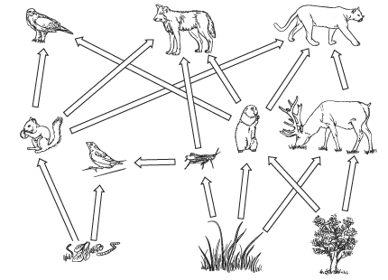
- What is this illustration called? _______________
- Circle a producer.
- Draw a square box around a primary consumer.
- Do the arrows point to the eaters or to the eaten? ________________
- Which animal is at the top of this ecosystem? How do you know? _____________________________ ______________________________________________________________________________
- What would happen if you removed the top animal of this ecosystem? __________________________ _______________________________________ _______________________________________
Name________________________
- What is this illustration called? _______________
- Circle a producer.
- Draw a square box around a primary consumer.
- Do the arrows point to the eaters or to the eaten? ________________
- Which animal is at the top of this ecosystem? How do you know? _____________________________ ______________________________________________________________________________
- What would happen if you removed the top animal of this ecosystem? __________________________ _______________________________________ _______________________________________
Name ___________________________
Circle the correct answer.
- What kind of things are rocks, water and temperature?
  - Biotic
  - Abiotic
  - Living
- What living things make their energy from sunlight?
  - consumers
  - decomposers
  - producers
- Where do the arrows on a food chain or food web point?
  - To the eaten
  - to the eater
- Place these organization levels in order from the smallest group to the largest:

ecosystem
biosphere
individual organism
community
population
Name ___________________________
Circle the correct answer.
- What kind of things are rocks, water and temperature?
  - Biotic
  - Abiotic
  - Living
- What living things make their energy from sunlight?
  - consumers
  - decomposers
  - producers
- Where do the arrows on a food chain or food web point?
  - To the eaten
  - to the eater
- Place these organization levels in order from the smallest group to the largest:

ecosystem
biosphere
individual organism
community
population
Name ____________________________

- An animal that catches and kills another animal is called a…
  - prey
  - producer
  - predator

- Food is a limiting factor when
  - a population is large
  - there is too much food
  - a population is small

- Animals helping each other is called
  - Parasitism
  - organism
  - mutualism

- What happened to other living things when the wolves in Yellowstone died out?
_______________________________________
_______________________________________
_______________________________________
Name ____________________________

- An animal that catches and kills another animal is called a…
  - prey
  - producer
  - predator

- Food is a limiting factor when
  - a population is large
  - there is too much food
  - a population is small

- Animals helping each other is called
  - Parasitism
  - organism
  - mutualism

- What happened to other living things when the wolves in Yellowstone died out?
_______________________________________
_______________________________________
_______________________________________
Use the vocabulary words to fill in the blanks
Population | Food chain | Biotic | Food web
Abiotic | Carnivores | community

- An animal that eats plants and other animals is called a(n) ________________
- A diagram that shows the feeding relationship between living things in an ecosystem is a(n) ______________________________
- Food webs show energy connections better than ________________________
- A river is a ____________________ part of an ecosystem
- All living things (plants and animals) are part of an ecosystems _______________
- Two or more individuals of the same species in the same ecosystem are a(n) _______________________
- All of the populations in an ecosystem together are called a(n) ________________
Use the vocabulary words to fill in the blanks
Population | Food chain | Biotic | Food web
Abiotic | Carnivores | community

- An animal that eats plants and other animals is called a(n) ________________
- A diagram that shows the feeding relationship between living things in an ecosystem is a(n) ______________________________
- Food webs show energy connections better than ________________________
- A river is a ____________________ part of an ecosystem
- All living things (plants and animals) are part of an ecosystems _______________
- Two or more individuals of the same species in the same ecosystem are a(n) _______________________
- All of the populations in an ecosystem together are called a(n) ________________

