Name _____________________
Match your vocabulary word with its definition.
Producer Consumer Scavenger Decompose
_________ | An organism that gets energy by breaking down the remains of dead organisms
_________ | A consumer that feeds on the bodies of dead animals
_________ | An organism that eats producers or other organisms
_________ | An organism that uses sunlight directly to make food

Omnivore Carnivore Herbivore
_________ | A consumer that eats only animals
_________ | A consumer that eats both plants and animals
_________ | A consumer that eats only plants

Energy Pyramid Food Chain Food Web
_________ | A list of organisms that eat each other for energy
_________ | A diagram that shows many different, but connected food chains in an environment
__________ | An illustration of how energy is transferred from the sun through different organisms
Name _____________________
Match your vocabulary word with its definition.
Producer Consumer Scavenger Decompose
_________ | An organism that gets energy by breaking down the remains of dead organisms
_________ | A consumer that feeds on the bodies of dead animals
_________ | An organism that eats producers or other organisms
_________ | An organism that uses sunlight directly to make food

Omnivore Carnivore Herbivore
_________ | A consumer that eats only animals
_________ | A consumer that eats both plants and animals
_________ | A consumer that eats only plants

Energy Pyramid Food Chain Food Web
_________ | A list of organisms that eat each other for energy
_________ | A diagram that shows many different, but connected food chains in an environment
__________ | An illustration of how energy is transferred from the sun through different organisms

Name _____________________

Meter Liter or Gram?
Scientists use the metric system to measure so that all scientists in the world use the same system. Can you label the unit that these measurement methods are using?

__________________ | __________________ | 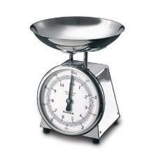  _________________
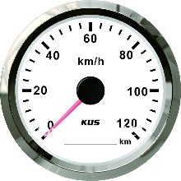  __________________ | 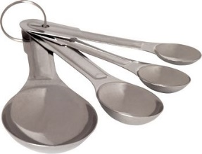  __________________ | __________________
a 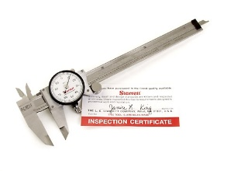  __________________ | __________________ | 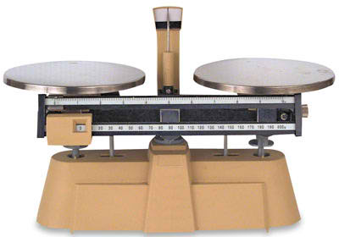  __________________
Name __________________________

Meter Liter or Gram?
Scientists use the metric system to measure so that all scientists in the world use the same system. Can you label the unit that these measurement methods are using?

__________________ | __________________ | _________________
__________________ | __________________ | __________________
a  __________________ | __________________ | __________________
Name _____________________

What’s the difference?
How are a food chain and a food web different? How are they the same?
Food Chain | Food Web
Same as Food Web: | Same as Food Chain:

Food Chain | Food Web
Different from Food Web: | Different from Food Chain

Name _____________________

What’s the difference?
How are a food chain and a food web different? How are they the same?
Food Chain | Food Web
Same as Food Web: | Same as Food Chain:

Food Chain | Food Web
Different from Food Web: | Different from Food Chain

Name _____________________

Meter Liter or Gram?
Scientists use the metric system to measure so that all scientists in the world use the same system. Can you label the unit of measure for each of these objects?
Label each object with meter, liter or gram

__________________ | __________________ | 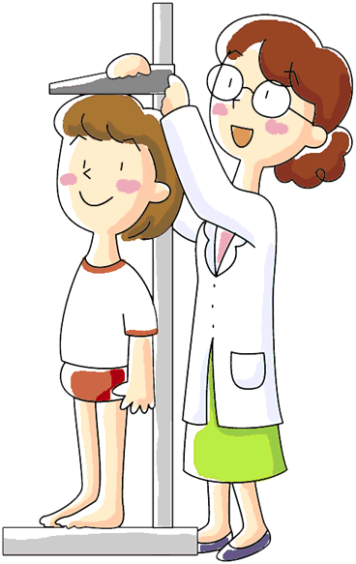  _________________
__________________ | __________________ | __________________
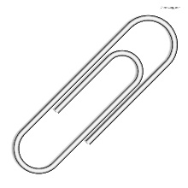  __________________ | __________________ | __________________
Name _____________________

Meter Liter or Gram?
Scientists use the metric system to measure so that all scientists in the world use the same system. Can you label the unit of measure for each of these objects?
Label each object with meter, liter or gram

__________________ | __________________ | _________________
__________________ | __________________ | __________________
__________________ | __________________ | __________________
Name _____________________
Vocabulary ES 1.2

Decomposer | An organism that gets energy by breaking down the remains of dead organisms
Scavenger | A consumer that feeds on the bodies of dead animals
Consumer | An organism that eats producers or other organisms
Producer | An organism that uses sunlight directly to make food
Carnivore | A consumer that eats only animals
Omnivore | A consumer that eats both plants and animals
Herbivore | A consumer that eats only plants
Food Chain | A list of organisms that eat each other for energy
Food Web | A diagram that shows many different, but connected food chains in an environment
Primary Consumer | Animals that eat primary producers - also known as herbivore
Energy Pyramid | An illustration of how energy is transferred from the sun through different organisms

Name _____________________
Vocabulary ES 1.2

Decomposer | An organism that gets energy by breaking down the remains of dead organisms
Scavenger | A consumer that feeds on the bodies of dead animals
Consumer | An organism that eats producers or other organisms
Producer | An organism that uses sunlight directly to make food
Carnivore | A consumer that eats only animals
Omnivore | A consumer that eats both plants and animals
Herbivore | A consumer that eats only plants
Food Chain | A list of organisms that eat each other for energy
Food Web | A diagram that shows many different, but connected food chains in an environment
Primary Consumer | Animals that eat primary producers - also known as herbivore
Energy Pyramid | An illustration of how energy is transferred from the sun through different organisms

Name _____________________
Vocabulary ES 1.3

Carrying Capacity | the largest population that an environment can support at any given time
Coevolution | The evolution of two species that is due to mutual influence – it often is good for both species
Commensalism | A relationship between two organisms where one organism benefits and the other is not affected
Mutualism | A relationship between two organisms in which both species benefit
Parasitism | A relationship between two organisms where one organism benefits and the other is harmed
Predator | An organism that kills and eats all or part of another organism
Prey | An organism that is killed and eaten by another organism
Symbiosis | A relationship between two different organisms in a single environment
Competition | When two or more populations compete for food, water, shelter, space, or sunlight
Camouflage | A prey adaptation that makes them harder to see
Warning coloration | A prey adaptation that makes an organism seem to be dangerous (even if they are not)

Name _____________________
Vocabulary ES 1.3

Carrying Capacity | the largest population that an environment can support at any given time
Coevolution | The evolution of two species that is due to mutual influence – it often is good for both species
Commensalism | A relationship between two organisms where one organism benefits and the other is not affected
Mutualism | A relationship between two organisms in which both species benefit
Parasitism | A relationship between two organisms where one organism benefits and the other is harmed
Predator | An organism that kills and eats all or part of another organism
Prey | An organism that is killed and eaten by another organism
Symbiosis | A relationship between two different organisms in a single environment
Competition | When two or more populations compete for food, water, shelter, space, or sunlight
Camouflage | A prey adaptation that makes them harder to see
Warning coloration | A prey adaptation that makes an organism seem to be dangerous (even if they are not)

