Era | Life | What Happened?
Cenozoic  65 million  years ago  to  present | 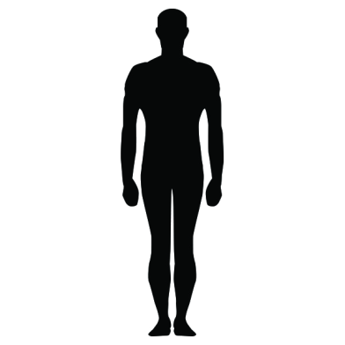  All Modern Life  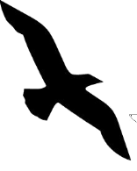  Humans  Mammals  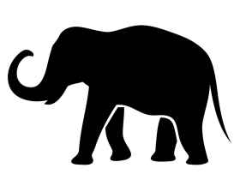  Fish  Birds | Only small animals survived including mammals and birds.  This is our era.
A meteor hit earth and all of the big animals died.
Mesozoic  251 million  years ago  stto  65 million  years ago | 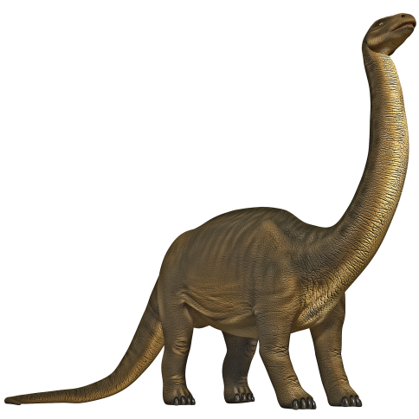  Dinosaurs  Small Mammals  Early Birds | The Age of the Dinosaurs  Early mammals appeared.
Paleozoic  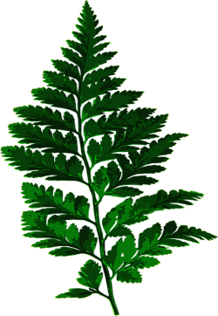  542 million  years ago  to  251 million  years ago | Trilobites  Insects  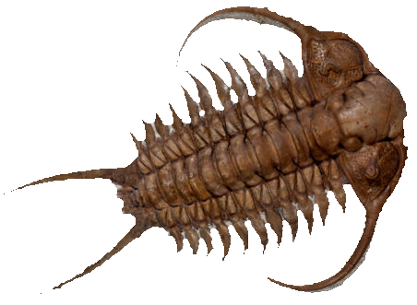  Fish | Animals got more complicated and some crawled out of the oceans at the end of the era.
Pre-Cambrian  4570million  years ago  to  542 million  years ago | simple single celled organisms  early plants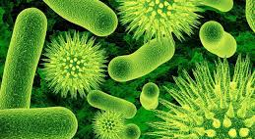 | Life began as  simple, single celled organisms in the  ocean. Plants and  animals began to  appear near the end.

