By __________________________________________
Geologic History
Era | Life | What Happened?
Cenozoic  65 million  years ago  to  present |  | Only small animals survived including mammals and birds.  This is our era.
A meteor hit earth and all of the big animals died.
Mesozoic  251 million  years ago  stto  65 million  years ago |  | The Mesozoic Era  is known as the  Age of the Dinosaurs  Early mammals appeared.

Pre-Cambrian

Mesozoic Era
Mesozoic

Paleozoic Era
Cenozoic

Cenozoic Era

Paleozoic

Pre-Cambrian Era
Paleozoic  542 million  years ago  to  251 million  years ago |  | Animals got more complicated and some crawled out of the oceans at the end of the era.  Trilobites are ancient ancestors of horse  shoe crabs.
Pre-Cambrian  4570million  years ago  to  542 million  years ago |  | life began as  simple, single celled organisms in the  ocean. Plants and  animals began to  appear near the end.
A

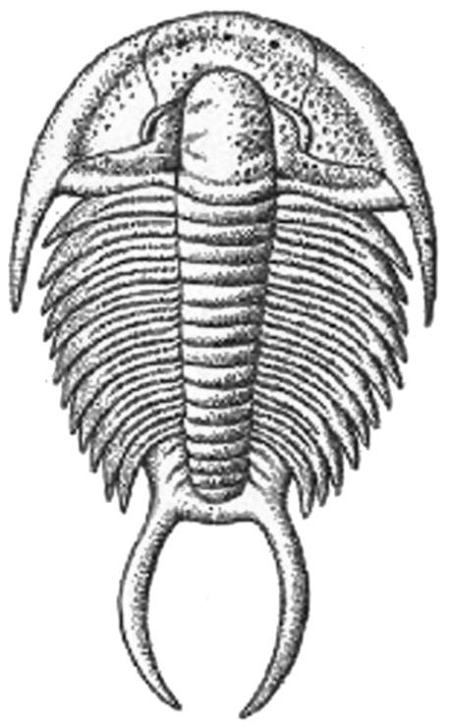
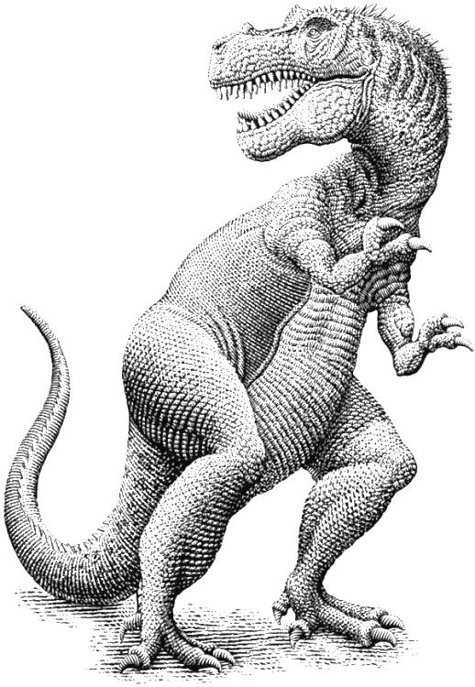 | 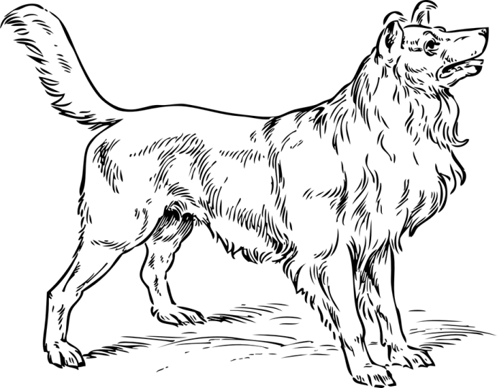
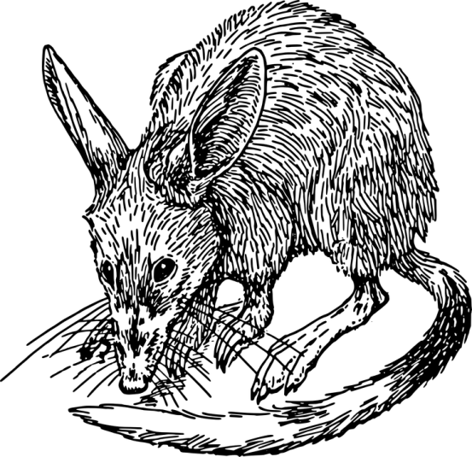 | 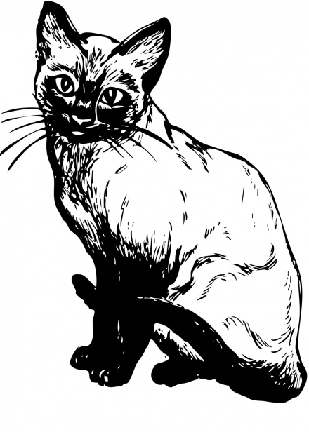 | 